HealthConnect Experience Lab
Week 5: Data Analytics Track, Initial HealthConnect Analytics Report
AnalystLab Africa Internship Programme

1. Review of My Week 4 Foundation
Before starting this week's practical work, here's a quick recap of where I left off in Week 4.
- Problem defined: understanding why so many HealthConnect patients miss their scheduled appointments, and which factors are most associated with that.
- Week 4 approach: review the dataset and data dictionary, assess data quality, define relevant business questions, and propose candidate KPIs before doing any calculations.
- Resources used: HealthConnect_Appointment_Data.csv and HealthConnect_Data_Dictionary.xlsx.
- Key assumptions and limitations identified: small gaps in distance_to_clinic_km and waiting_time_minutes (under 2% each), the synthetic nature of the dataset, and the need to treat Cancelled appointments separately from No Show.
- Proposed focus for Week 5: clean the missing values, calculate the KPIs identified in Week 4, and begin the analysis to answer the business questions.

2. Data Preparation
I started this week by cleaning the two columns flagged in Week 4. I checked whether the missing values were concentrated in a particular appointment outcome, and they were not, the gaps looked randomly distributed rather than tied to a specific pattern.
Column | Missing (before) | Action Taken | Value Used
distance_to_clinic_km | 90 (1.8%) | Filled with the column median | 8.7 km
waiting_time_minutes | 60 (1.2%) | Filled with the column median | 24 minutes
I used the median rather than the mean because it is not pulled around by outliers, and it gives a realistic, typical estimate for the missing entries. I also re-checked for duplicates and inconsistent values, and found none, matching what I saw in Week 4. The original dataset file was left untouched, and the cleaned version was saved separately as HealthConnect_Appointment_Data_cleaned.
One thing worth flagging: waiting_time_minutes has values recorded even for No-Show and Cancelled appointments, which is a little odd logically since a patient who never showed up should not have a recorded waiting time. This looks like an artifact of the synthetic dataset rather than something to fix, but it is worth noting as a data limitation.

3. Exploratory Data Analysis
With the cleaned data, I looked at how the no-show rate shifts across the different variables in the dataset. Here is what stood out.

3.1 Booking Lead Time
Lead Time Band | No-Show Rate
0 to 3 days | 24.8%
4 to 14 days | 32.6%
15 to 30 days | 43.2%
31+ days | 60.5%
This is the strongest pattern in the whole dataset. The longer a patient books ahead, the more likely they are to miss the appointment.

3.2 Prior No-Show History
Patients with at least one previous no-show attend at a lower rate (55.4% no-show) than patients with a clean history (43.5% no-show), a clear and steady relationship.

3.3 Distance to Clinic
No-show rate rises gradually with distance: 46.4% under 5km, 47.5% between 5 and 15km, and 54.1% at 15km or more. A real but smaller effect than lead time or history.

3.4 Reminders
Sending a reminder lowers the no-show rate from 51.4% to 47.4%. Among the individual channels, SMS performs best at 45.8%, ahead of Email at 48.4% and WhatsApp at 49.8%.

3.5 Weaker or No Effect
Gender, age group, appointment type, day of week, and time of day all showed very little variation, staying within a narrow 43 to 51% range. Waiting time showed essentially no relationship with no-show, which makes sense given the data limitation noted above.

4. KPI Development
Based on the exploratory analysis, I selected the 5 strongest KPIs out of the candidates proposed in Week 4.

KPI 1: Overall No-Show Rate
- Definition: the percentage of all appointments where the patient did not attend.
- Why it matters: establishes the baseline scale of the problem.
- Calculation: 48.5% of all 5,000 appointments ended in a no-show.
- Business question: what factors are most strongly associated with patients missing appointments?
- Interpretation: nearly half of all appointments are missed, confirming this is significant enough to justify the deeper breakdowns below.

KPI 2: No-Show Rate by Booking Lead Time Band
- Definition: no-show rate grouped by how far in advance the appointment was booked.
- Why it matters: tests whether booking timing affects attendance.
- Calculation: 0 to 3 days: 24.8%, 4 to 14 days: 32.6%, 15 to 30 days: 43.2%, 31+ days: 60.5%.
- Business question: how does booking lead time affect the likelihood of a no-show?
- Interpretation: the no-show rate more than doubles between same-week bookings and bookings made a month or more ahead, making this the strongest lever identified in the analysis.

KPI 3: No-Show Rate by Prior No-Show History
- Definition: no-show rate grouped by whether the patient has any previous no-shows on record.
- Why it matters: tests whether past behaviour predicts future risk.
- Calculation: 0 prior no-shows: 43.5%, 1 or more prior no-shows: 55.4%.
- Business question: does a patient's appointment history predict future no-shows?
- Interpretation: patients with a history of missing appointments are noticeably more likely to miss again, a strong candidate for a simple risk-flagging rule.

KPI 4: No-Show Rate by Distance Band
- Definition: no-show rate grouped by distance from the patient's home to the clinic.
- Why it matters: tests whether travel distance is a barrier to attendance.
- Calculation: under 5km: 46.4%, 5 to 15km: 47.5%, 15km or more: 54.1%.
- Business question: does distance to the clinic affect attendance?
- Interpretation: there is a real but moderate effect, patients living farther away are somewhat more likely to miss appointments.

KPI 5: No-Show Rate by Reminder Status
- Definition: no-show rate grouped by whether a reminder was sent, and by channel.
- Why it matters: tests whether reminders are effective at improving attendance.
- Calculation: no reminder: 51.4%, reminder sent: 47.4%. By channel: SMS 45.8%, Email 48.4%, WhatsApp 49.8%.
- Business question: does sending a reminder, and the channel used, reduce the rate of missed appointments?
- Interpretation: reminders help, but modestly, suggesting they work best combined with the higher-impact factors above rather than as a standalone fix.

5. Dashboard
All five KPIs, along with supporting breakdowns by gender, were brought together into a Power BI dashboard, shown below.
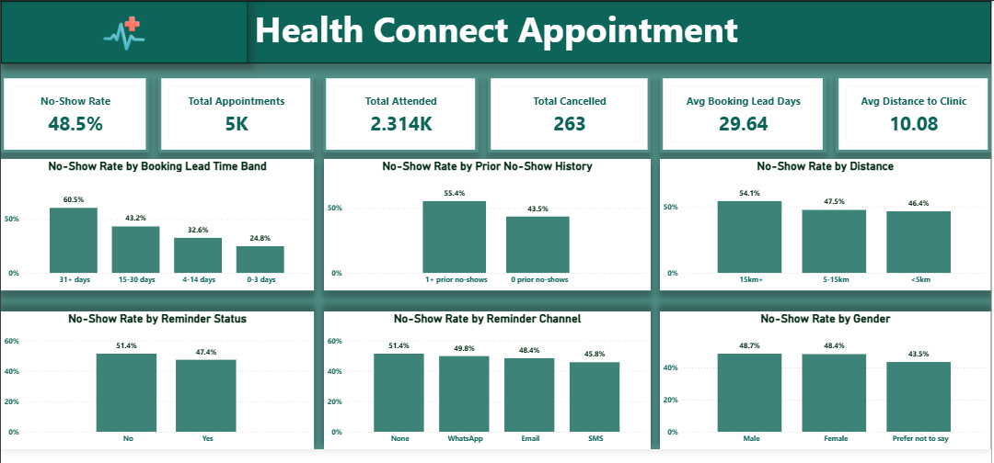
The top row of cards gives the headline numbers (overall no-show rate, total appointments, total attended, total cancelled, average booking lead time, and average distance to clinic). The charts below break attendance down by the factors that mattered most in the analysis.

6. Key Findings
- 1. Booking lead time is the single biggest driver of no-shows. Patients booking 31 or more days ahead no-show at 60.5%, more than double the rate of same-week bookings.
- 2. A patient's no-show history strongly predicts future no-shows. Patients with a prior no-show attend at 55.4% no-show versus 43.5% for those with a clean record.
- 3. Distance to the clinic has a moderate effect on attendance. No-show rate rises from 46.4% under 5km to 54.1% at 15km or more.
- 4. Reminders help modestly, and SMS is the most effective channel. Sending any reminder lowers no-show rate by about 4 points, and SMS outperforms Email and WhatsApp.
- 5. Demographic factors show little to no effect on attendance. Gender and age group both stayed within a narrow band, the real drivers are behavioural and logistical, not who the patient is.

7. Business Recommendations
- Add a mid-point reminder or confirmation step for appointments booked far in advance, rather than relying on a single reminder close to the date.
- Flag patients with a history of no-shows for extra follow-up, such as a confirmation call, ahead of their appointment.
- Explore telehealth appointment options or transport support for patients living farther from the clinic.
- Make SMS the default reminder channel where a patient's number is on file, since it shows the strongest effect among the channels tested.
- Focus interventions on behaviour and logistics (lead time, history, distance, reminders) rather than demographic targeting, since demographics showed little predictive value.

8. Limitations
- Imputed values: distance_to_clinic_km and waiting_time_minutes both had small gaps filled with the median. This is a reasonable estimate, not the true recorded value, for those specific appointments.
- Synthetic data: the dataset is fictional, so these findings demonstrate a sound analytical approach rather than reflecting a real clinic's patients.
- Waiting time inconsistency: waiting_time_minutes is recorded even for No-Show and Cancelled appointments, which does not fully make sense logically and limits how much this variable can be trusted for anything beyond attended visits.
- Correlation, not causation: these findings show association, not proof of cause. For example, long lead times are linked to higher no-shows, but other unmeasured factors could also be at play.
- Repeat patients: 1,696 patients account for 5,000 appointments, so patient-level patterns (like repeat no-show behaviour) should ideally be validated at the patient level in future work, not just the appointment level.

9. Cross-Track Collaboration
- Track interacted with: Data Science.
- Information exchanged: the KPI findings and business insights from this report, particularly the strength of booking lead time and prior no-show history as predictors.
- Why it was relevant: the Data Science track is defining a machine learning model to predict no-shows, and the variables that matter most in this exploratory analysis are strong candidates for that model's input features.
- What changed or improved as a result: sharing these findings early means the Data Science track can prioritise booking_lead_days and previous_no_shows as likely high-value features, rather than testing every variable with equal weight from scratch.

10. Review of Assumptions, Limitations, Risks and Dependencies
- Still relevant: the synthetic nature of the dataset, and the need to treat Cancelled appointments separately from No-Show in KPI calculations.
- Resolved: the missing values in distance_to_clinic_km and waiting_time_minutes have now been addressed through median imputation.
- Changed: the waiting_time_minutes limitation is now better understood, it is not just missing data, but also logically inconsistent for non-attended appointments.
- New issue discovered: no strong single-variable predictor exists on its own, which suggests a combination of factors (lead time and history together) may be needed for any future predictive model, this is now flagged for the Data Science track.
- Potential impact: if these limitations are not accounted for, KPI figures and any future model could overstate confidence in individual factors.
- How to address: continue documenting definitions clearly, and re-validate the cleaned data before building further analysis or models on top of it.

